SUSTAINABLE OUTREACH AND UNIVERSAL LEADERSHIP LIMITED
(SOUL)



HUMAN RESOURCE MANAGEMENT

GAP ANALYSIS DOCUMENT

1.Master Data / Screens
  - Employee:

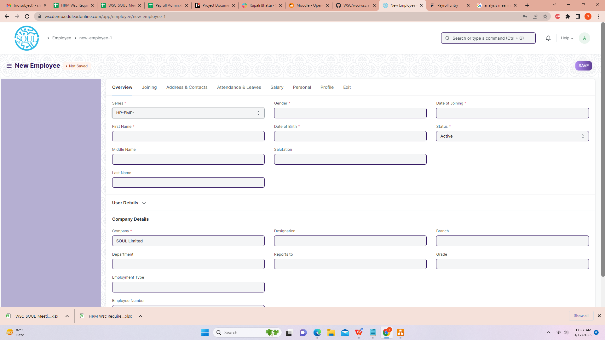

Business Requirement:
- Multiple Department/Designation allotted to an employee should be present in the Employee Screen under “Company Details”.

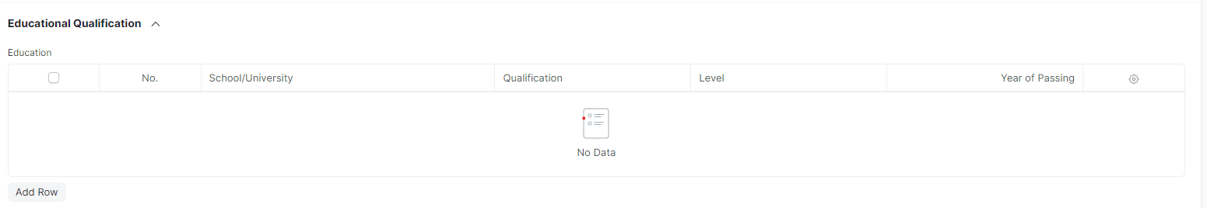

- In the Employee screen,the “educational qualifications” should be fetched directly from the “job applicant”.

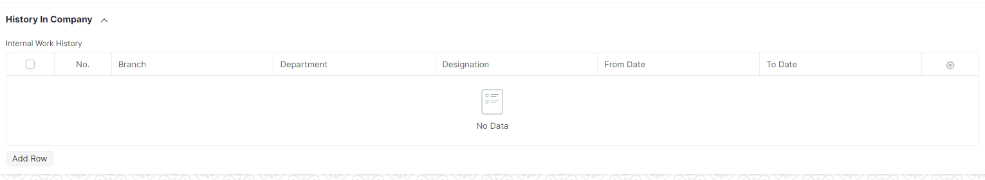

- In the Employee screen,in “History In Company”the employee promotion and employee transfer hierarchy should be maintained(along with multiple department or designation allotted).

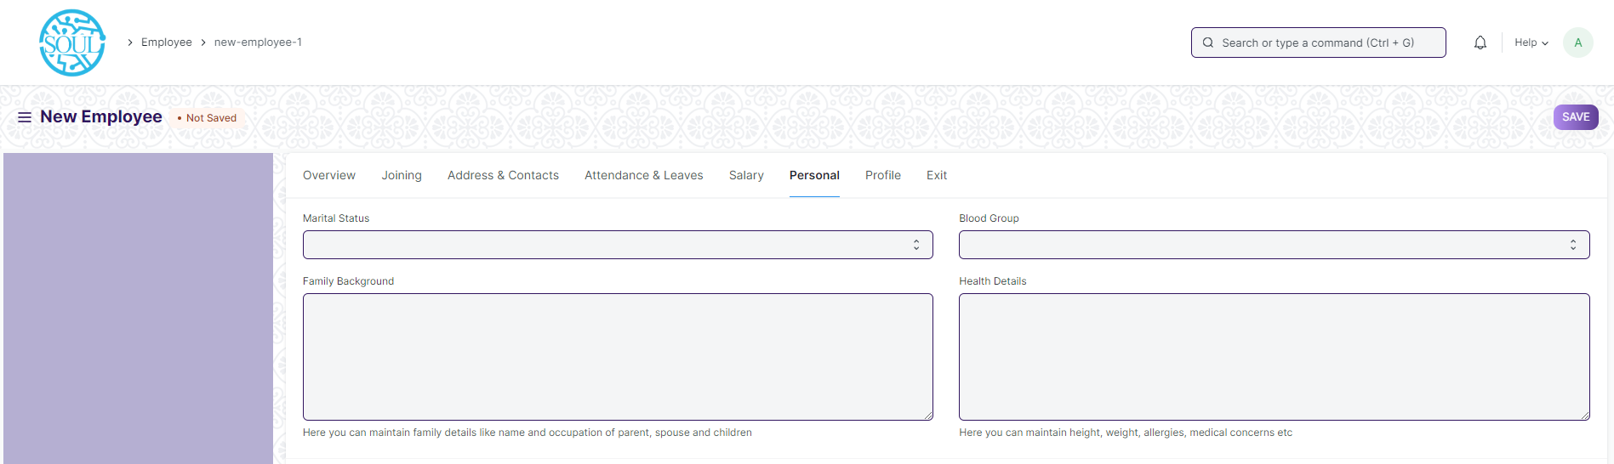

- In “Family Background Details” following fields need to be added:
- Father’s name
- Mother’s name
- Spouse name
- Occupation details of Father,Mother and Spouse
- Annual Income( Father,Mother and Spouse)
- Address and Contact details.
- Health Details like Height,Weight,medical concern for every family members(Father,Mother and Spouse).

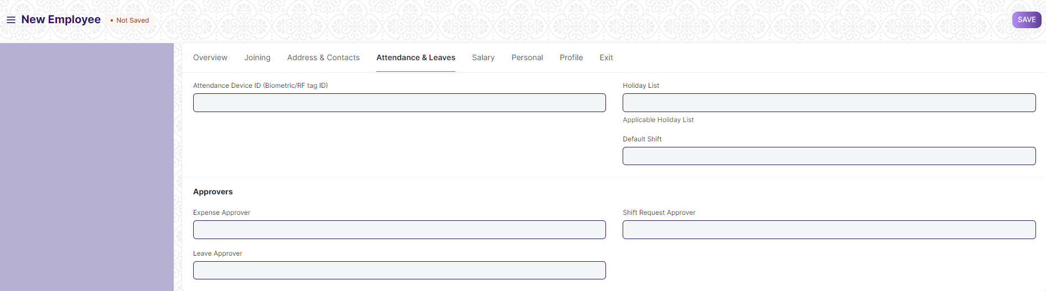

- In “Approver”,there should be two level of Approver
- Recommending Authority and
- Approving Authority for Expenses,Shift Request and Leaves.

- Based on the amount of expenses there should be different level of Approvers.

- “Health Insurance Details” should consists of fields like:
- Health Insurance name
- Health Insurance Number
- Company Name

- “Notice Period ” details like No. Of Days,Status(Served/Not Served) should be present.

  - Employee Type :

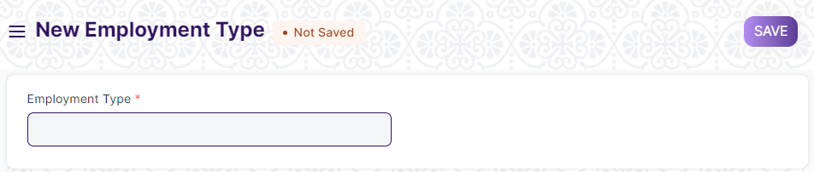

- No changes needed as discussed.

  - Branch :

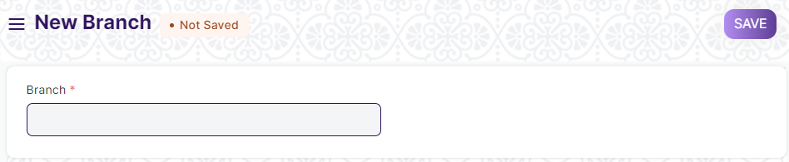

- No changes needed as discussed.

  - Department :

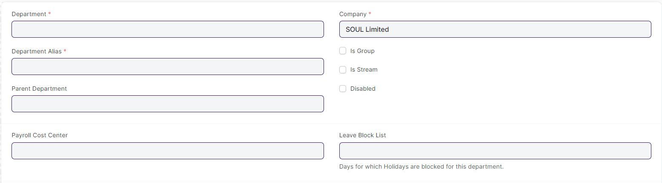

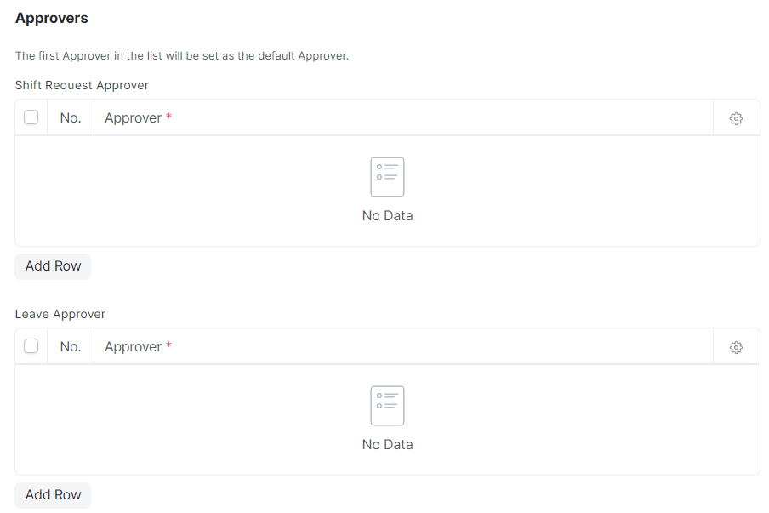

- No changes needed as discussed.

  - Designation :

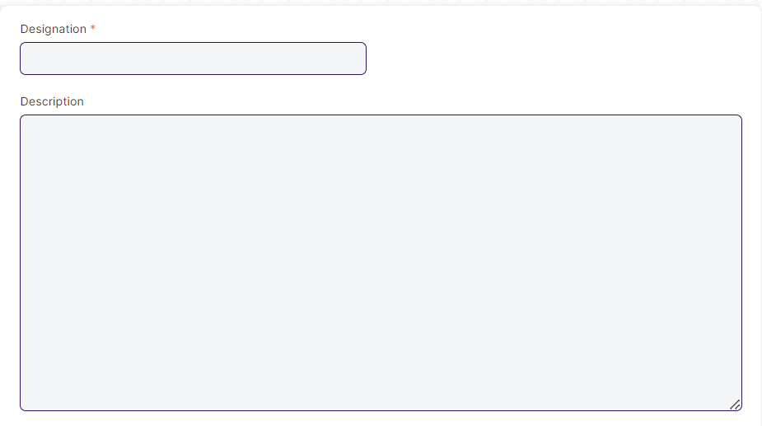

- No changes needed as discussed.

  - Employee Grade :

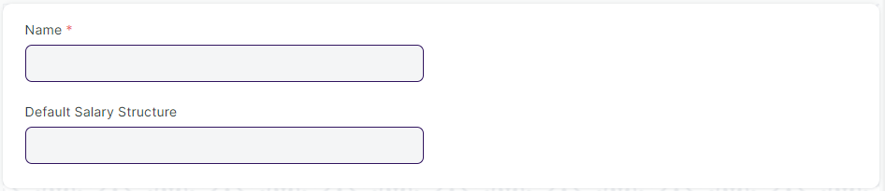

- No changes needed as discussed.

  - Employee Group :

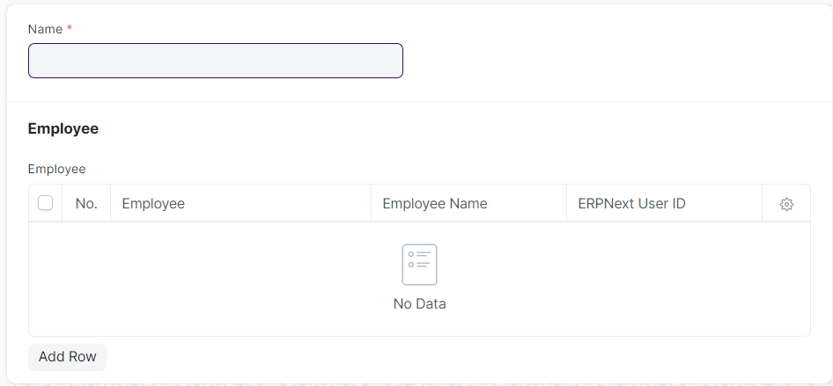

- No changes needed.

  - Employee Health Insurance :



- No changes needed .

2.Recruitment
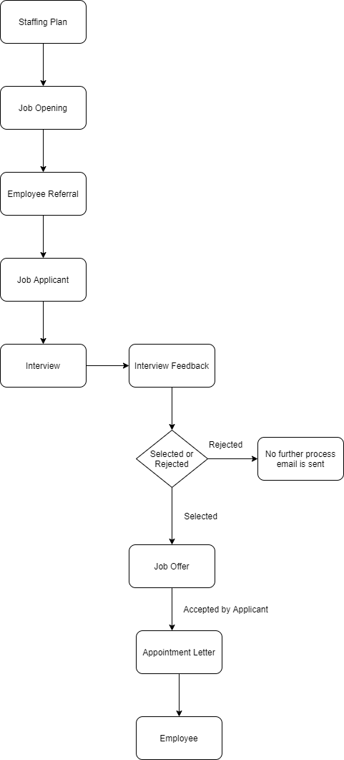

Fig:Existing Recruitment Process

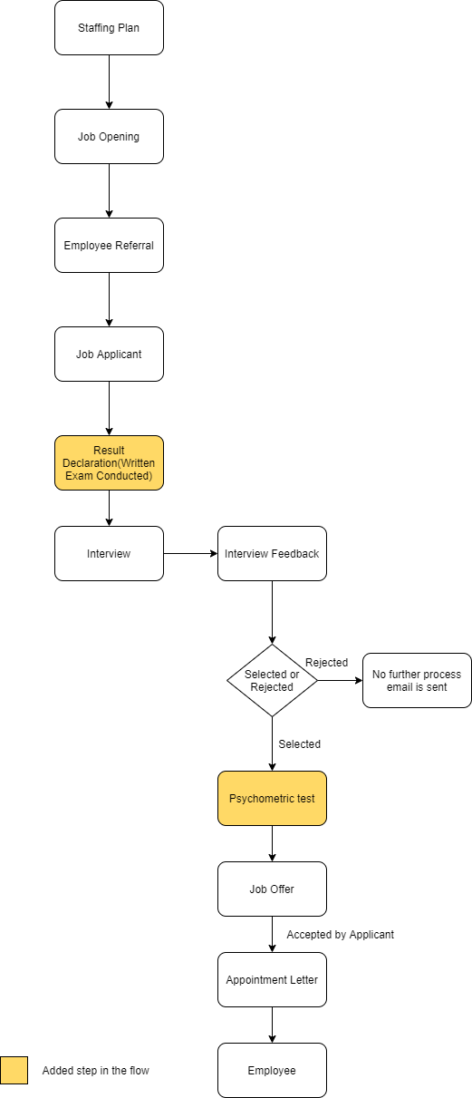

Fig:Required Recruitment Process
  - Staffing Plan :

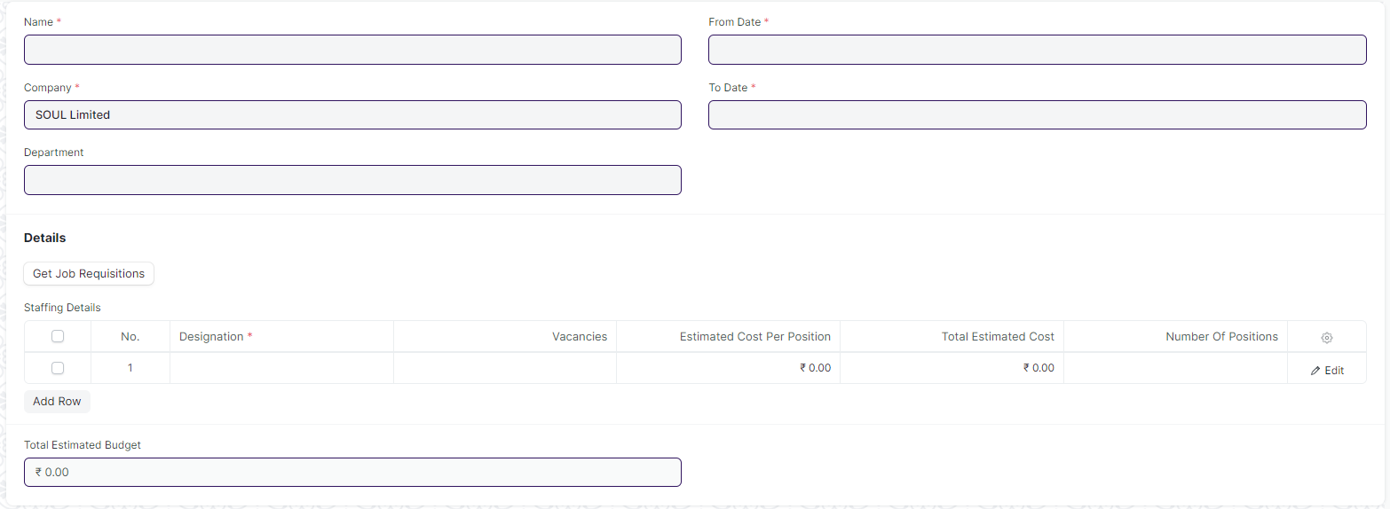

- No changes needed as discussed.

  - Job Opening :

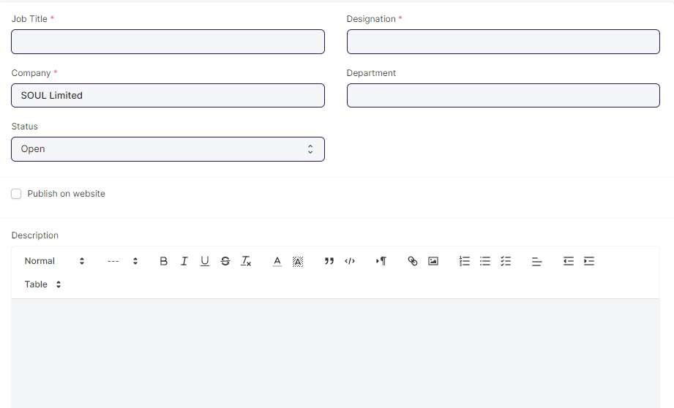

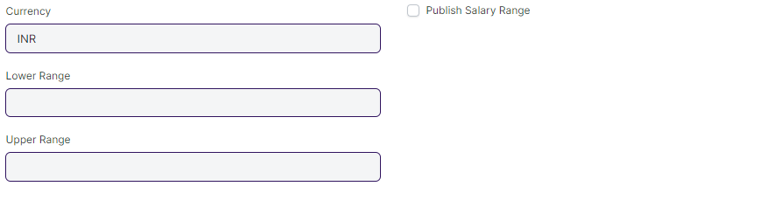

- No changes needed as discussed.

  - Employee Referral :

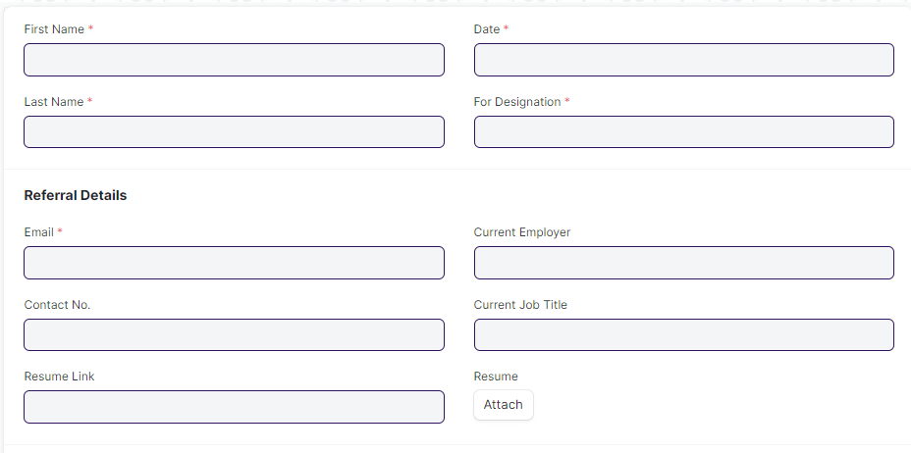
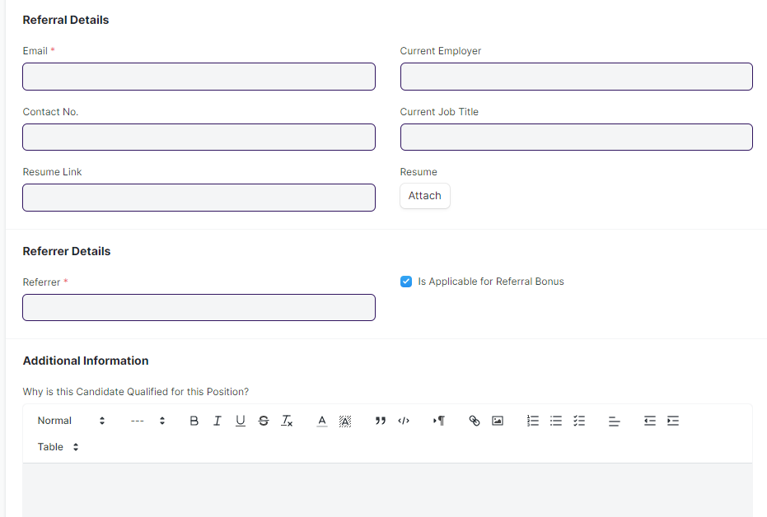

- No changes needed as discussed.

  - Job Applicant :

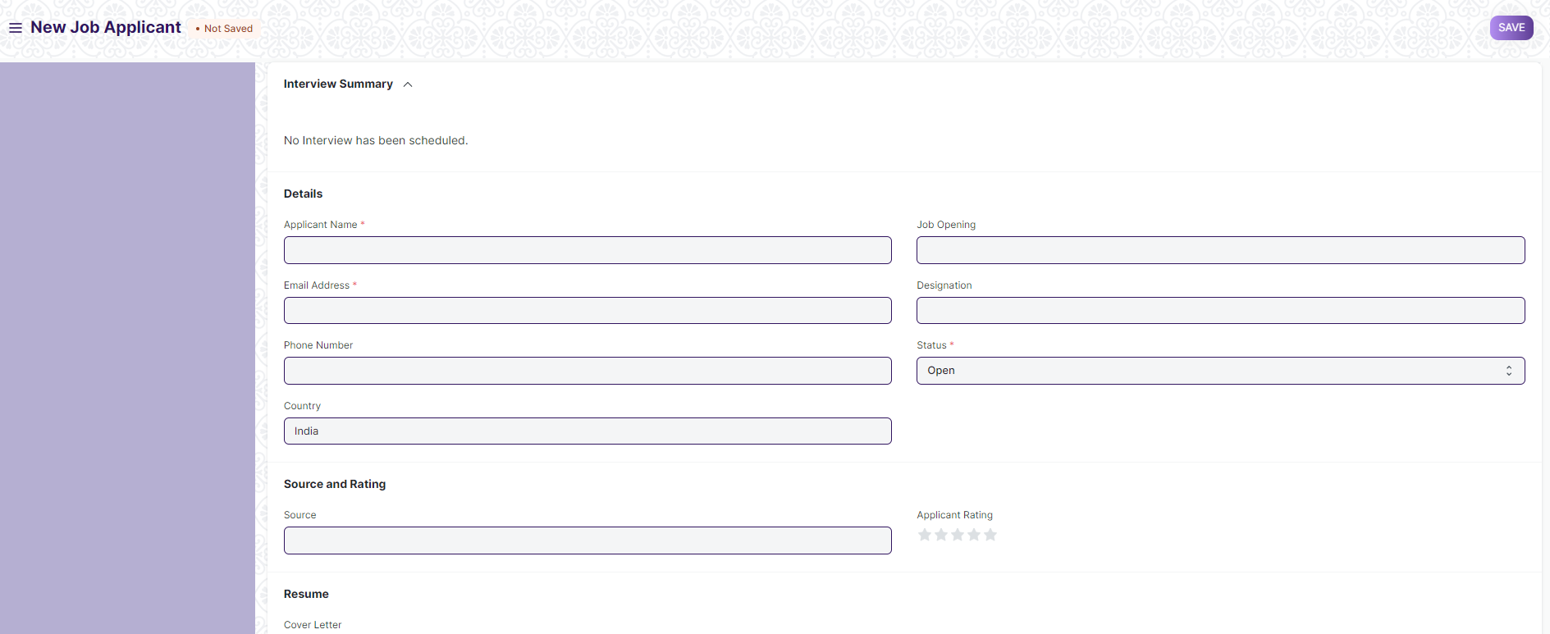

Business Requirement:
- There should be a “table” to maintain “Educational Qualification” with the fields like:
- Name of School/University
- Qualification
- Level(Graduate/Post Graduate and so on)
- Year of Passing
- Percentage
- Subjects(Major and Optional)

- There should be “Attach” field for uploading various required documents like 10th Mark sheet,12th Mark sheet and other required educational documents as well as other documents.
Remark: Mandatory fields will be discussed later.

  - Interview Type :

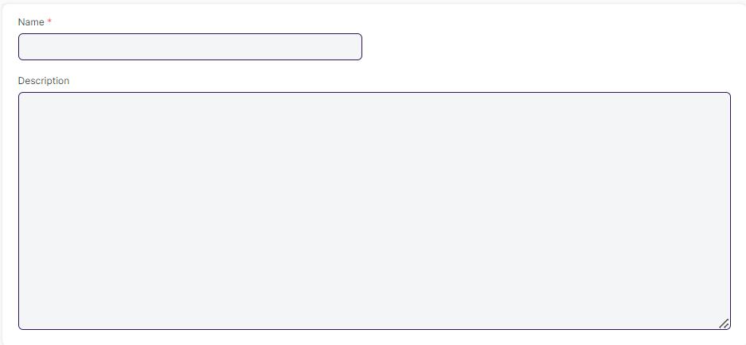

- No changes needed as discussed.

  - Interview Round :

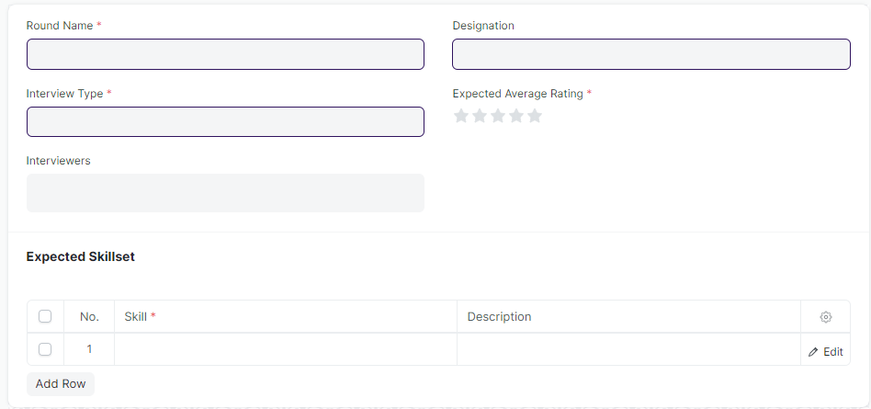

- “Expected Average Rating” field should be numeric should .

  - Interview :

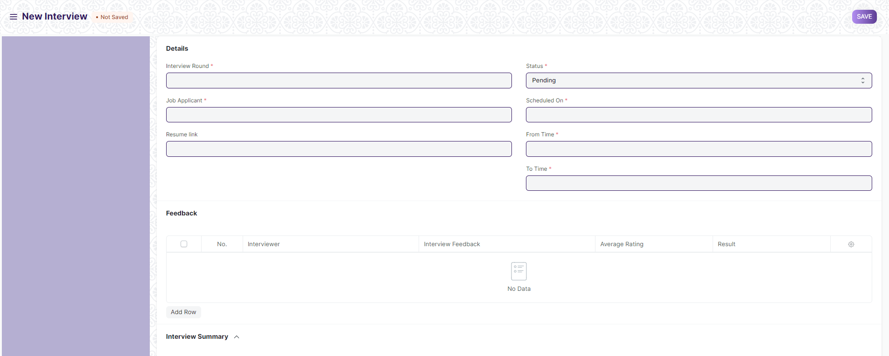

Business Requirement:
- In Interview Screen,in”Feedback table” the average rating field of the Feedback child table should be a numeric field rating from 0-5/0-10

  - Interview Feedback :

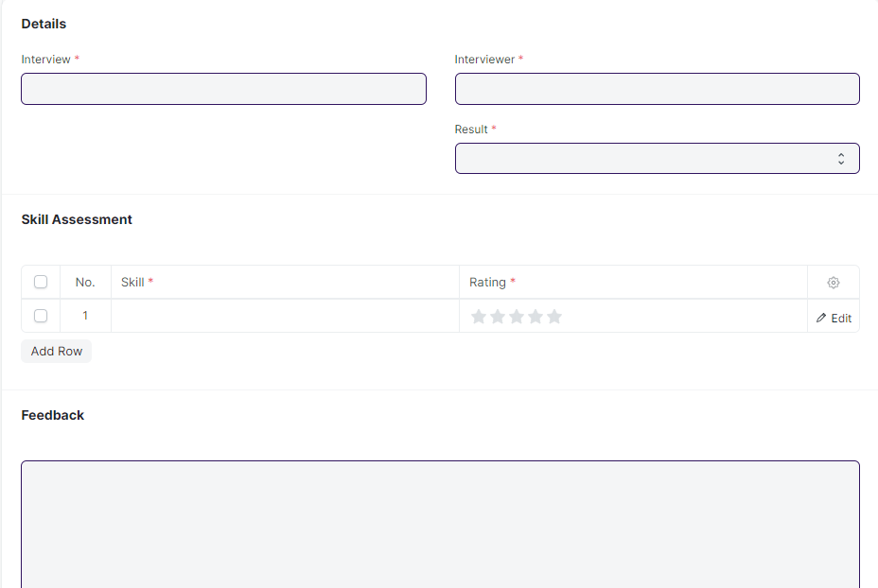

- “Rating” field should be numeric should .

  - Job Offer :

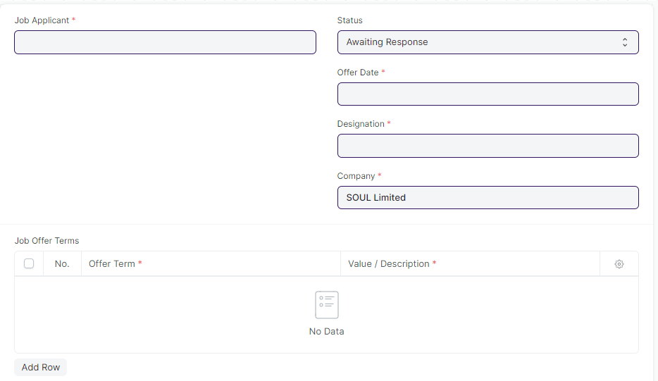
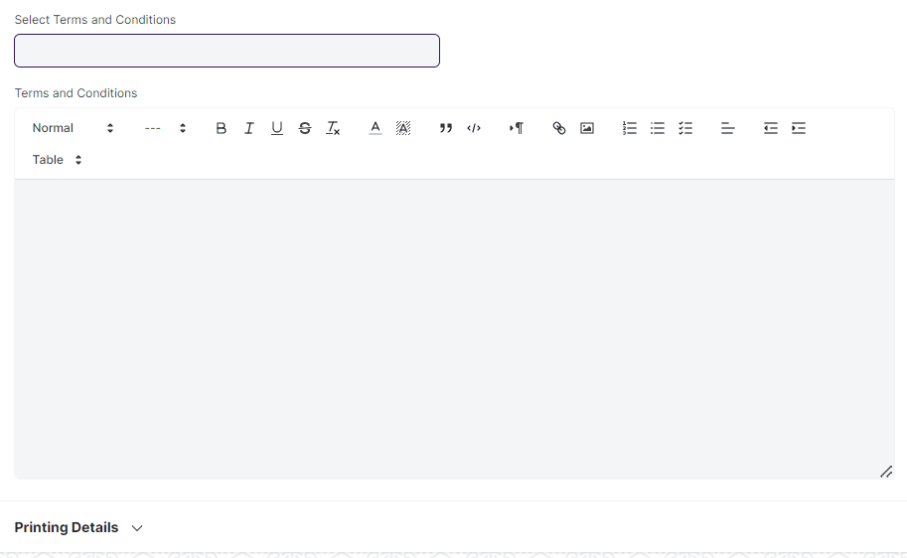

Business Requirement :

- Job Offer for selected applicant will be triggered by email in a certain format(provided by WSC).

Remark :

- The feature to trigger mail will be discussed .

  - Appointment Letter Template :

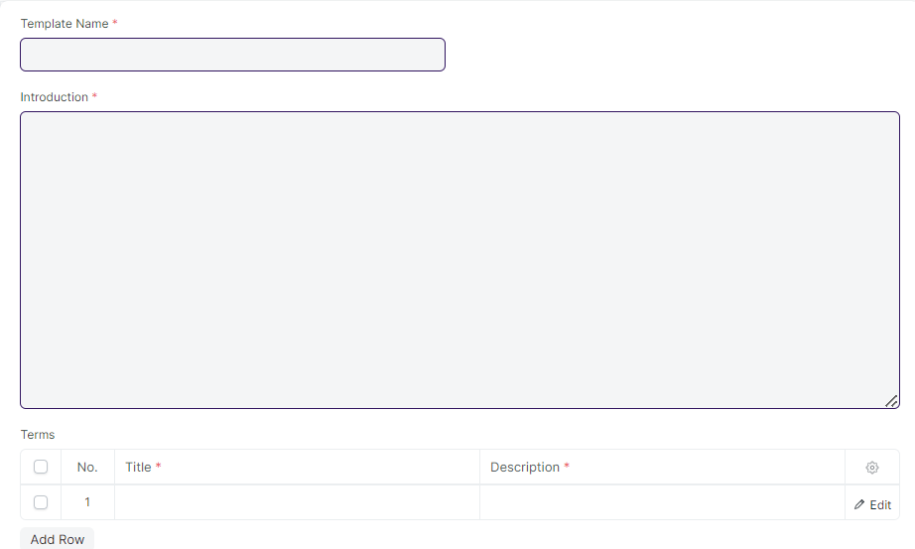

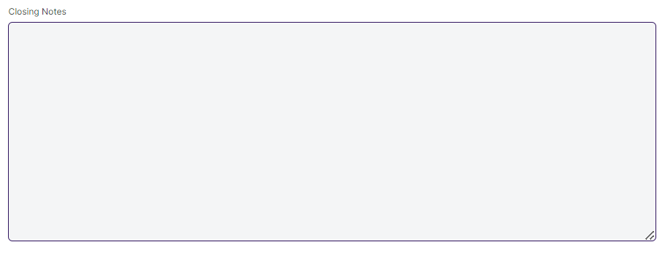

- No changes needed as discussed.

  - Appointment Letter :

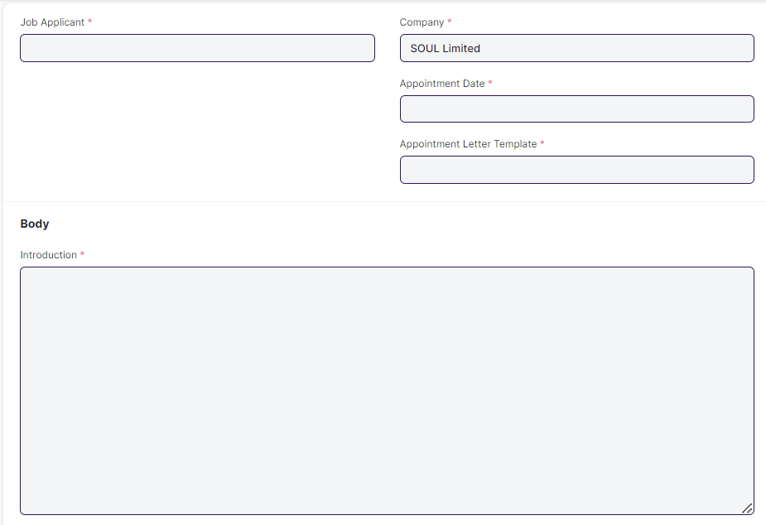
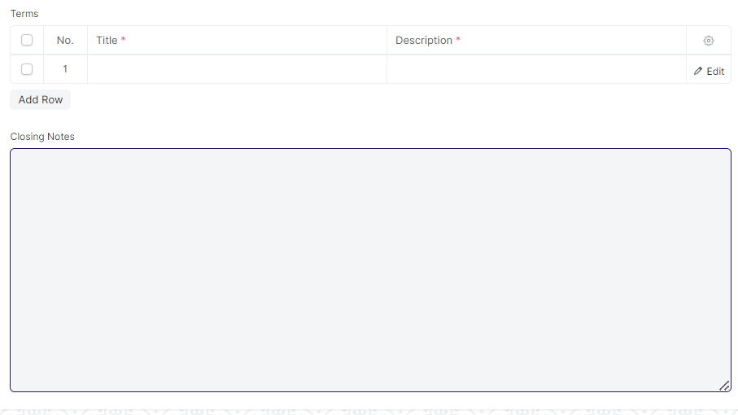

- No changes needed as discussed.

3. Employee Life-cycle

3.1 Employee Promotion:

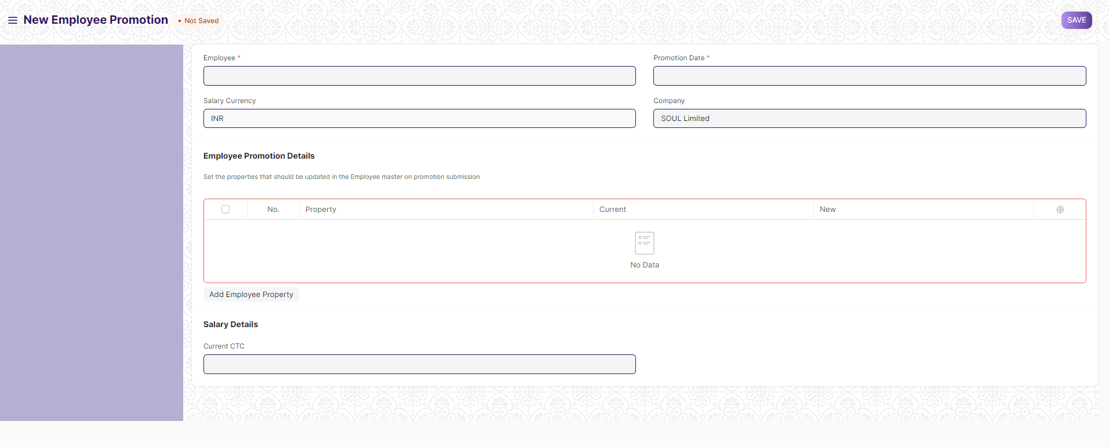

Business Requirement:
- There should be “Attach” field for uploading various required documents as a proof .
Remarks:Number of attached fields and labels will be discussed.

3.2 Employee Separation:

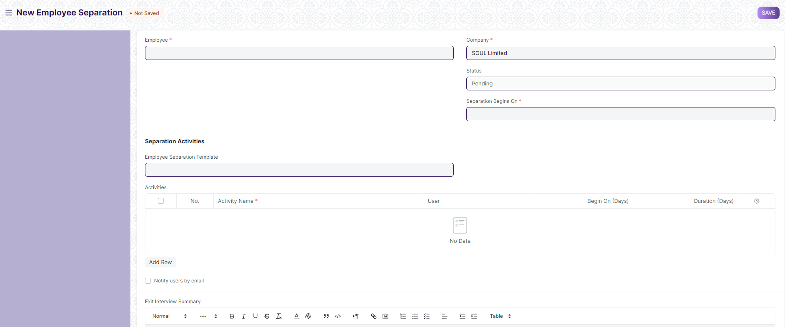

Business Requirement:
- There should be “Attach” field for uploading various required documents as a proof .
Remarks:Number of attached fields and labels will be discussed.

3.3 Employee Grievance:

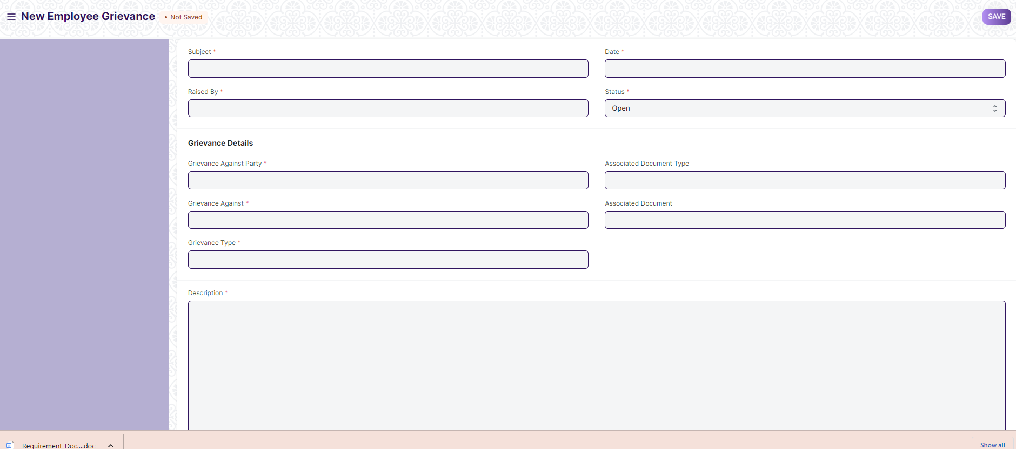

Business Requirement:
- There should be “Attach” field for uploading various required documents as a proof .
Remarks:Number of attached fields and labels will be discussed.

- There should be a “Workflow” for Employee Grievance and accordingly the authorities should be notified.
Remarks:In the existing application we do not have a workflow.Required workflow along with the concerned authorities need to be discussed.

- There should be a provision of “Acceptance of Resignation” in Employee Separation screen.
Remarks:In the existing application we do not have a workflow.Workflow to be developed in this way:
Once the resignation process is started , there should be a feature to manage the notice period , and the tentative final resignation date in the employee screen. The higher authority also be able to accept the final resignation before the final resignation date.

- There should be fields like:
- Notice Period Days
- Tentative Final Resignation Date

3.4 Employee On-boarding Template :
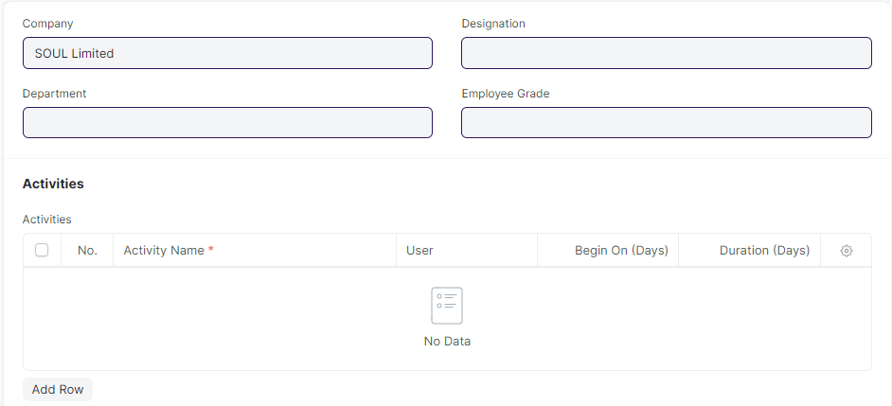

- No changes needed as discussed.

3.5 Employee On-boarding :

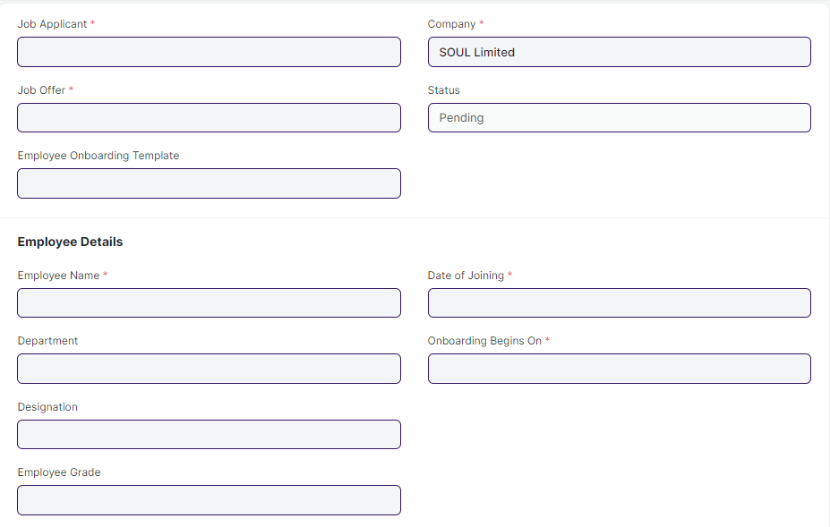
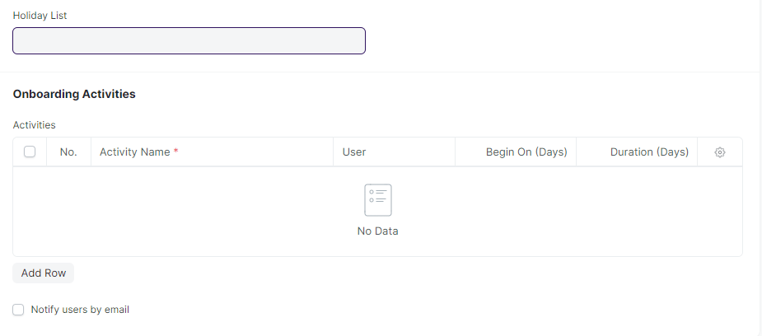

- No changes needed as discussed.

3.6 Employee Skill Map :

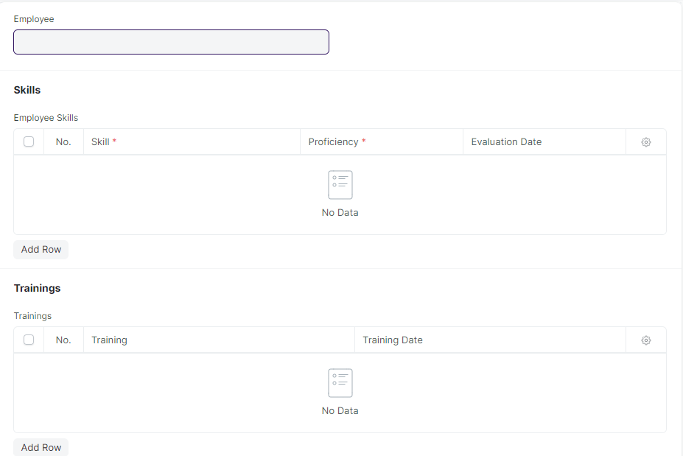

- No changes required as discussed.

3.7 Employee Transfer :

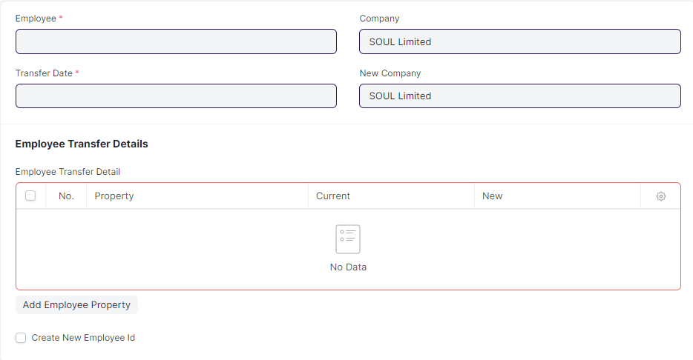

- No changes needed as discussed.

3.8 Grievance Type :

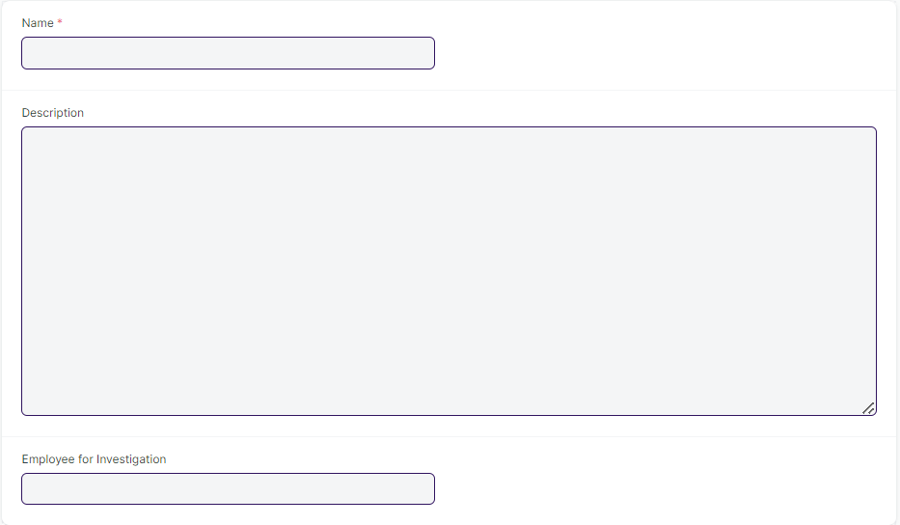

- No changes needed as discussed.

3.9 Employee Separation Template :

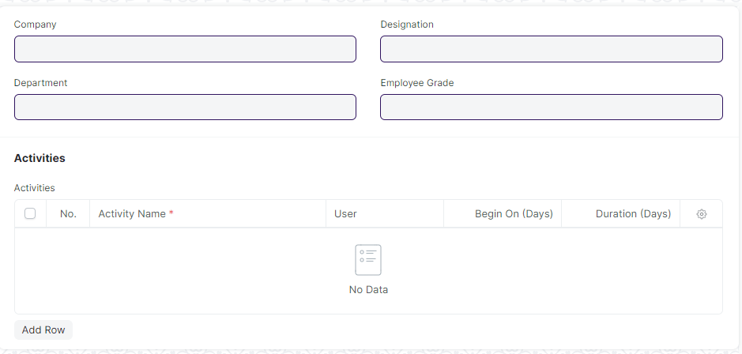

- No changes needed as discussed.

4. Shift & Assignment :

4.1 Shift Type :

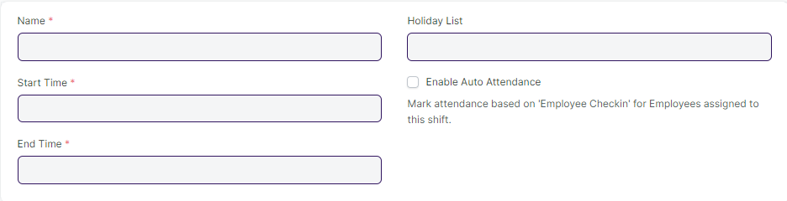

- No changes needed as discussed.

4.2 Shift Request :

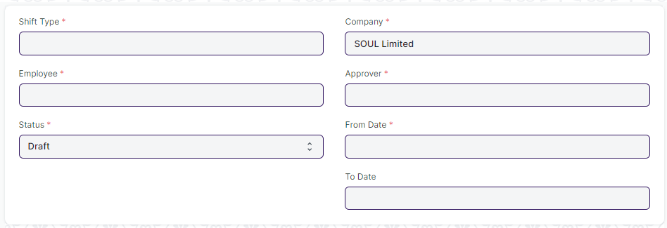

- No changes needed as discussed.

4.3 Shift Assignment :

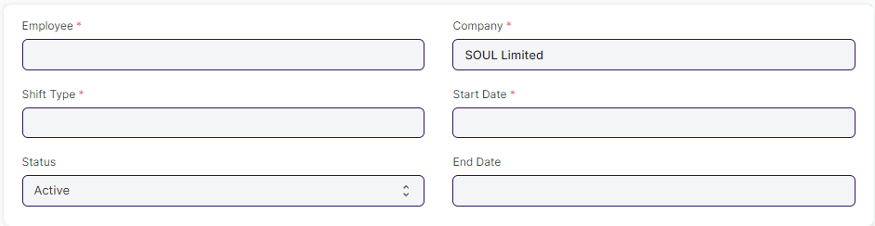

- No changes needed as discussed.

5 . Leaves :

5.1 Holiday List :

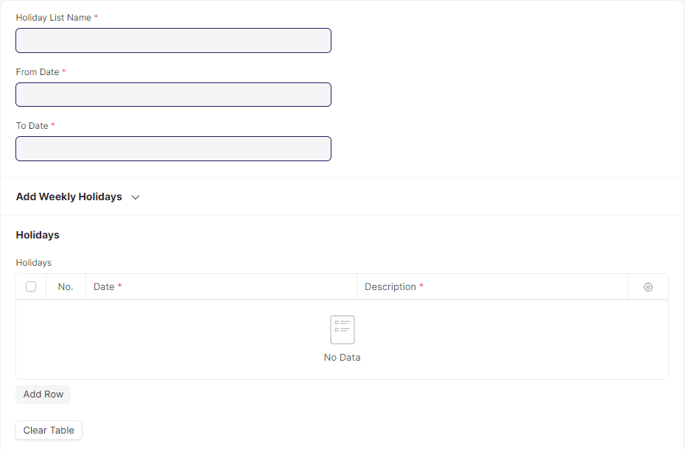

- No changes needed as discussed.

5.2 Leave Type :

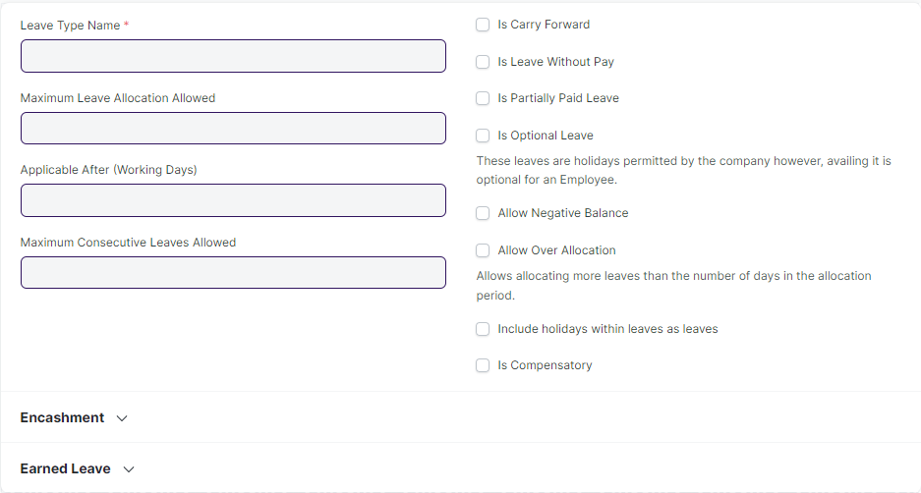

- No changes needed as discussed .

5.3 Leave Policy Assignment :

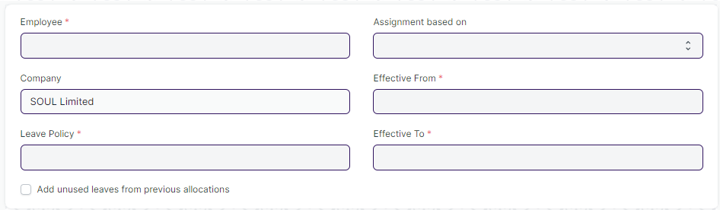

- No changes needed as discussed.

5.4 Leave Application :

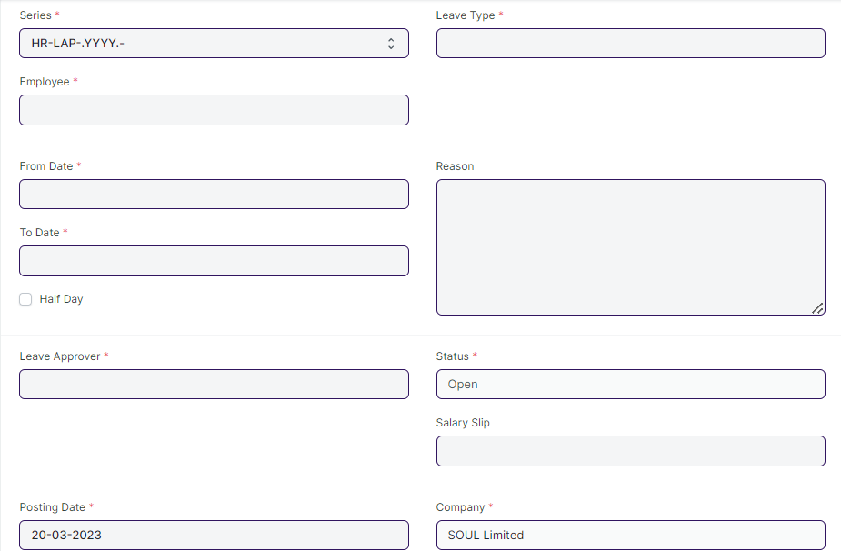

Business Requirement :

- In Leave Application,there should be a Calendar view.The Calendar will show the data of Leaves with the dates of last months.

- When a person applies for leave , an email along with the link will be triggered to the approver.

5.5 Leave Allocation :

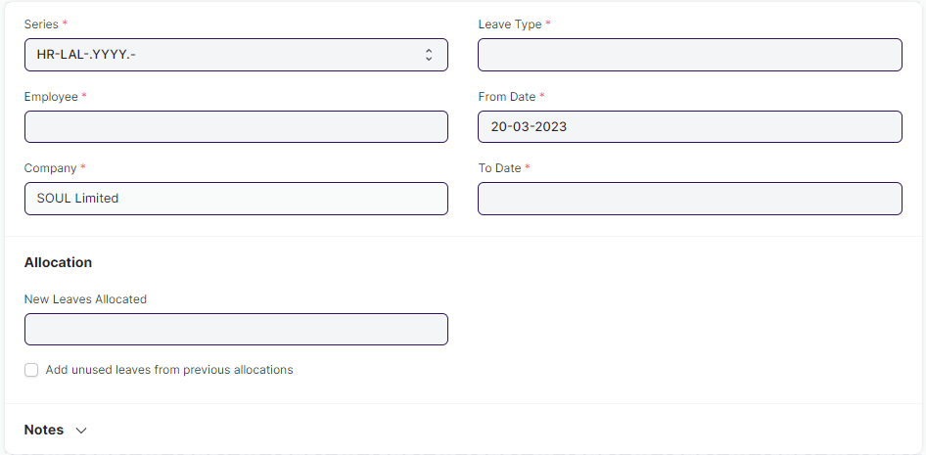

- No changes needed as discussed.

5.6 Leave Encashment :

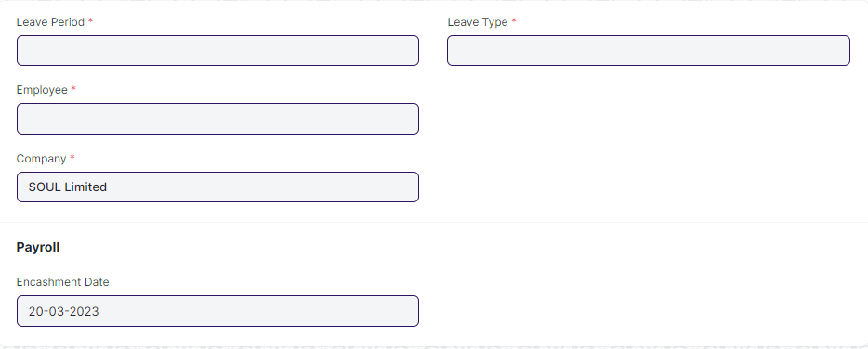

- No changes needed as discussed.

5.7 Leave Block List :

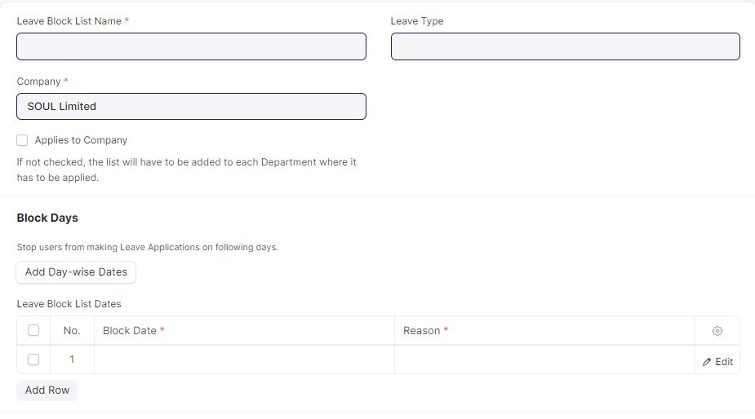

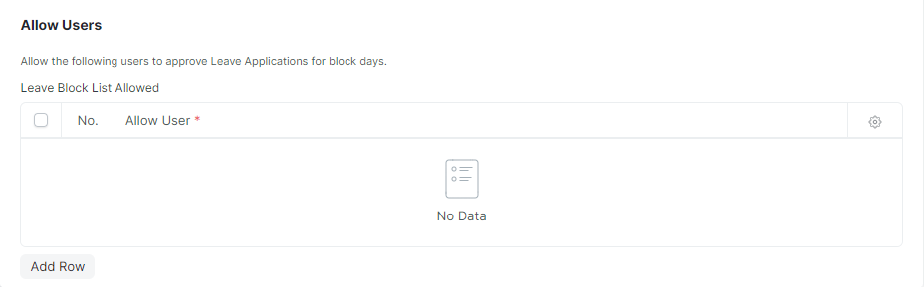

- No changes needed as discussed.

5.8 Compensatory Leave Request :

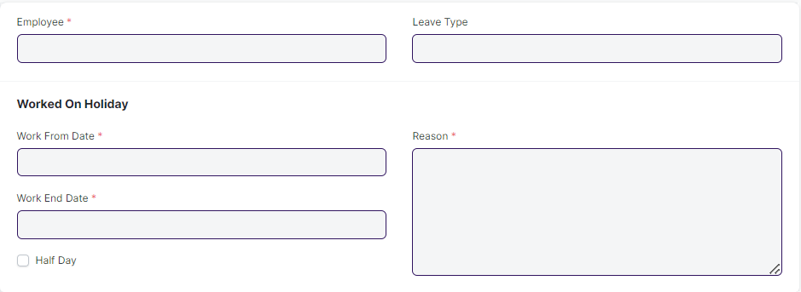

- No changes needed as discussed.

6 . Attendance :

  - Employee Attendance Tool :

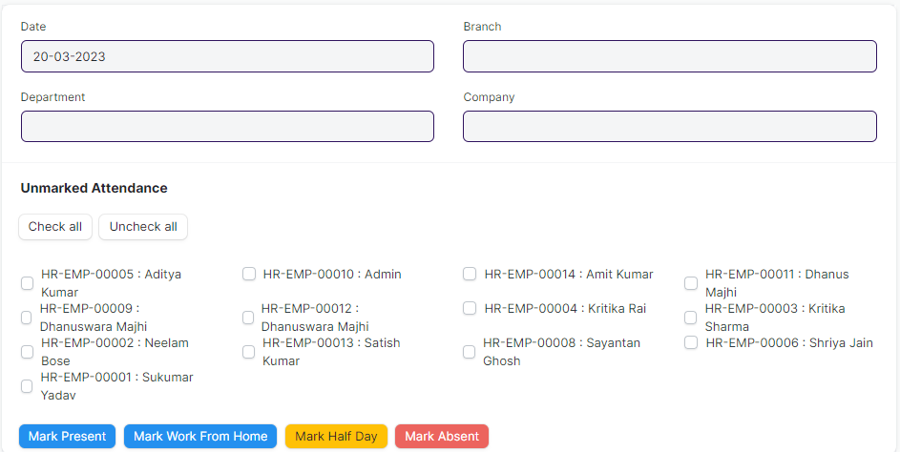

- No Changes needed as discussed.

  - Attendance :

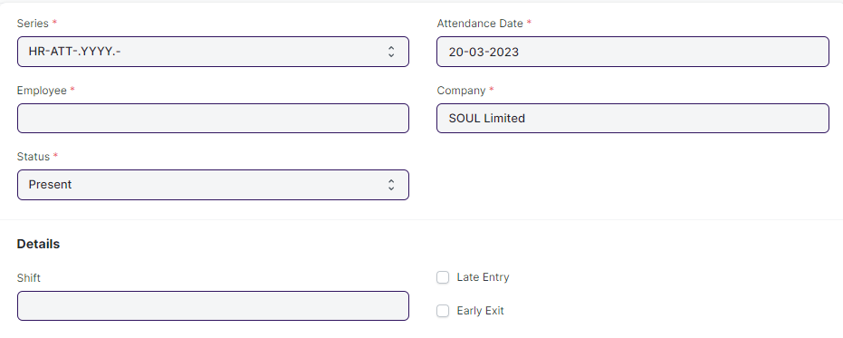

- No changes needed as discussed.

  - Attendance Request :

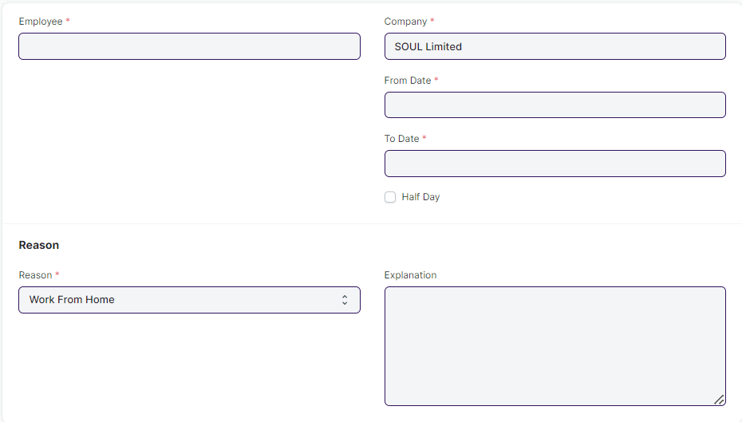

Business Requirement :

- Future Date Attendance Should be requested.

  - Employee Check in :

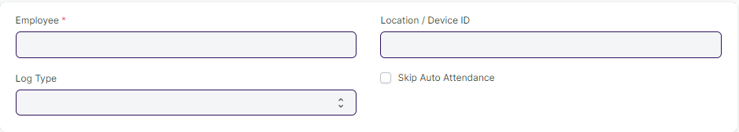

- No changes required as discussed.

7 . Performance :

  - Appraisal :

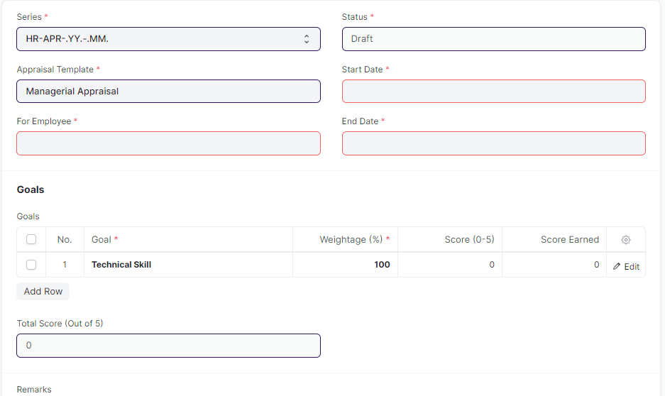

- No changes needed as discussed.

  - Appraisal Template :

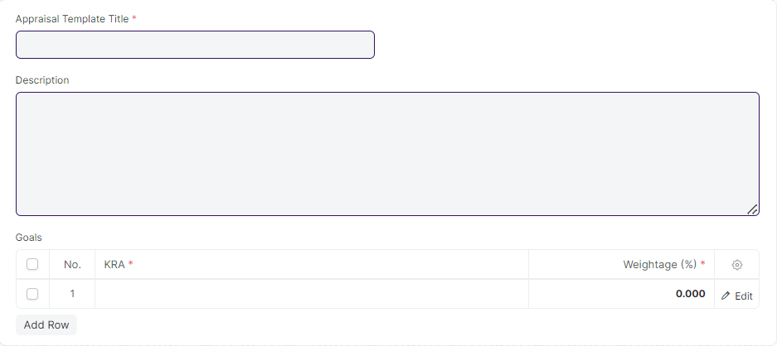

- No Changes needed as discussed.

8 . New Requirements :

- There should be feature to conduct the Post job selection a before giving job offer to a selected applicant (Feature to do a Psychometric test.)

- There should be two level of Approver (Recommending Authority and Approving Authority) for expenses ,shift and leave.

- If some one has taken a leave , after approval of the head without leave application . Then the day of his leave , he will be marked as absent.To clear his absent attendance to leave there should be a provision for post leave clearance.

- In recruitment process, a provision of result declaration should be present.

